Course notes

Probability primer:
https://www.dropbox.com/scl/fi/slat7wb8qigf6qmnkhpi4/probability-primer.pdf?rlkey=066v4tta3jpzu8xiz50esnfsw&dl=0

Topic 1. Physical limits - vision, prior, signal-to-noise, discrimination etc.

Week 1 [Jan 6]
- Intro
  - Big picture, DOF versus non-linearity
  - What in biology is interesting?
    - Replication
    - Evolution
    - Search
- Photons counting (bialek’s book on biophysics - Chapter 2)
  - K = 6 experiments and poisson distribution based model for photon counting
Bialek’s book - https://books.google.ca/books?id=MLYJ5Rz3GLwC&printsec=frontcover&redir_esc=y#v=onepage&q&f=false

- Mixture of gaussians for single rod cell response

Week 2 [Jan 13] - distinguishing between alternatives, and single cell response (bialek’s book)
- Mixture of gaussians for single rod cell response - continued
- Measuring the poisson distribution rather than yes/no answer
- Integrating signals - rectify before combining

Week 3 [Jan 20] - Entropy, mutual information and Input - output for vision (bialek’s book)
- Laughlin’s input-output function as a cumulative distribution for maximum information transfer.
- Do the calculation with and without noise

Topic 2. Optimizing information

Week 4 [Jan 27]: Search - Chemotaxis and Infotaxis (Vergessola & Shraiman, Nature)
- Pizza problem to shows greedy policy maximizes the change in entropy
- When the distribution is not known Infotaxis works better than the greedy policy - simulations by Rob Heineman.
Week 5 [Feb 3] : Optimal policy, idea from reinforcement learning [TBD]

Topic 3. Evolutionary dynamics

Week 6 [Feb 10]: Evolutionary history, where do bacteria live and their turnover. Basics population dynamics and numbers. Evolutionary dynamics and Luria-Delbruck. [Exam during the tutorial on Feb 13]

Evolutionary history:

We discussed the evolutionary history of life and its changes in the class today. Here is a link for more information and much of what we discussed.

https://en.wikipedia.org/wiki/Timeline_of_the_evolutionary_history_of_life

https://en.wikipedia.org/wiki/History_of_life

Where do bacteria live?
Oceans and sub-surface layer

https://en.wikipedia.org/wiki/Marine_microorganisms

https://en.wikipedia.org/wiki/Deep_biosphere

How many bacteria are around and their turnover?

What drives evolution?

Genomes mutate creating diversity, and the environment selects individuals that are fitter, and the cycle goes on.

Provides information and numbers on genome mutations:
https://book.bionumbers.org/what-is-the-mutation-rate-during-genome-replication/

Bacterial numbers and evolution:
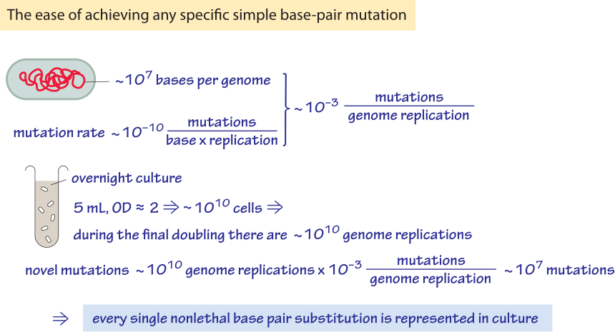

Human evolution:

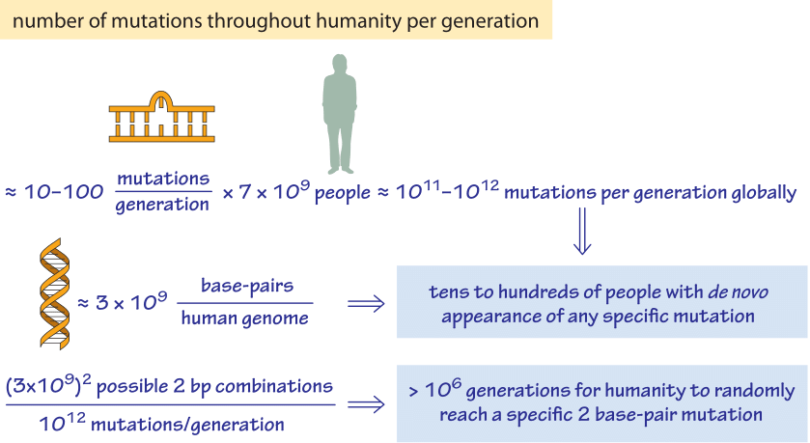

Week - [Feb 17]: BREAK
Week 7 [Feb 24]: How bacteria grow? Scott/Hwa model of growth, Size control.
Refs:
M. Scott, C. W. Gunderson, E. M. Mateescu, Z. Zhang and T. Hwa (2010) Inter-dependence of cell growth and gene expression: Origins and consequences. Science 330: 1099-1102.

M. Scott, S. Klumpp, E. M. Mateescu and T. Hwa (2014) Emergence of robust growth laws from optimal regulation of ribosome synthesis. Molecular Systems Biology 10: 747.

Week 8 [March 3]: Basic pop-gen
- Fate of mutations
  - Neutral model with binomial. Show drift is stronger in smaller populations. Fixation time ~N.
  - Beneficial mutation is better in larger pop. 1/N and s. Desai-Fisher argument.
  - Fixation prob and time in large populations. Branching process.

Tutorial - simulations for fate of mutations and Luria-delbruck

Week 9 [March 10]. Beneficial mutations dynamics (Immune context?)

T cells and B Cells
Germinal centers

https://pmc.ncbi.nlm.nih.gov/articles/PMC1931526/

Regulation, bet hedging and Kelly’s criteria, entropy again

Week 10 [March 17]: Cancelled due to travel.

Week 11 [March 24]: Simpson’s paradox and snowdrift game

Week 12 [March 31]: Final presentations. Exam in tutorial.

—----
Physics of behavior
More development - nonlinear dynamics
- Kinetic proofreading
- Immune discrimination - Francois et al.
- Segmentation clock
- Precise adaptation
- Akshit-mehta - mean-field diversity calculation
- Reddy - belman calculation with reinfircemtn learning framework
Population dynamics OR Dynamical systems
- Muller’s ratchet
- Clonal interference
- Immune system intro and application

